MISC - Item level/Policy Level

1. Duplicate riskcode

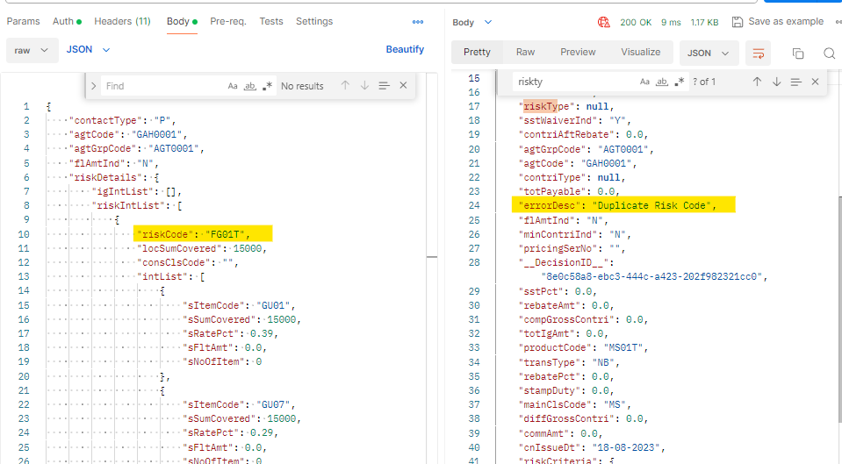

1. sItemCode , when I give wrong one , calc happened

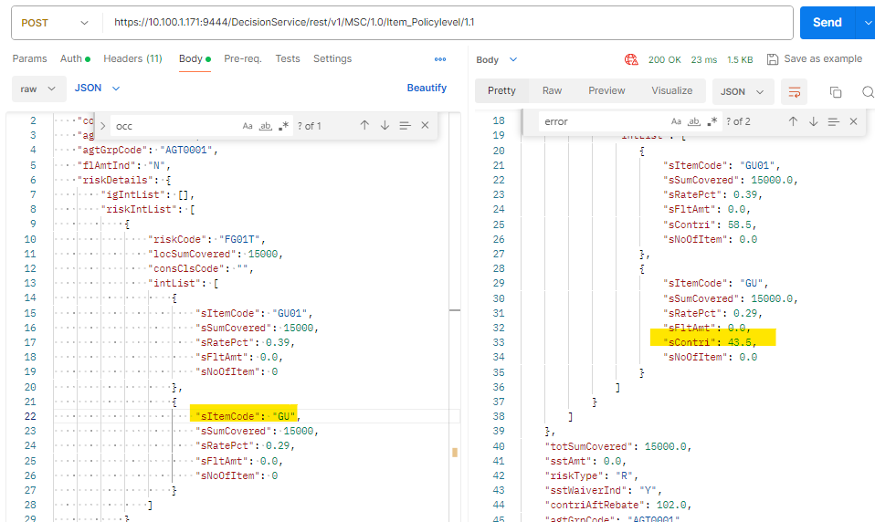

And it is handled in rule flow,

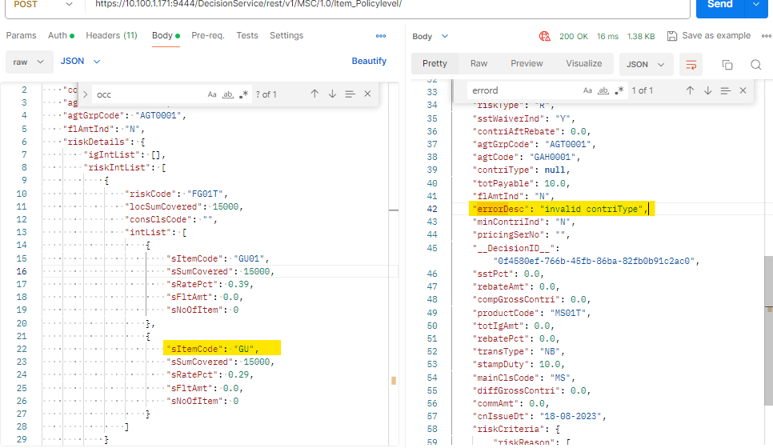

1. sContri – calculation handled

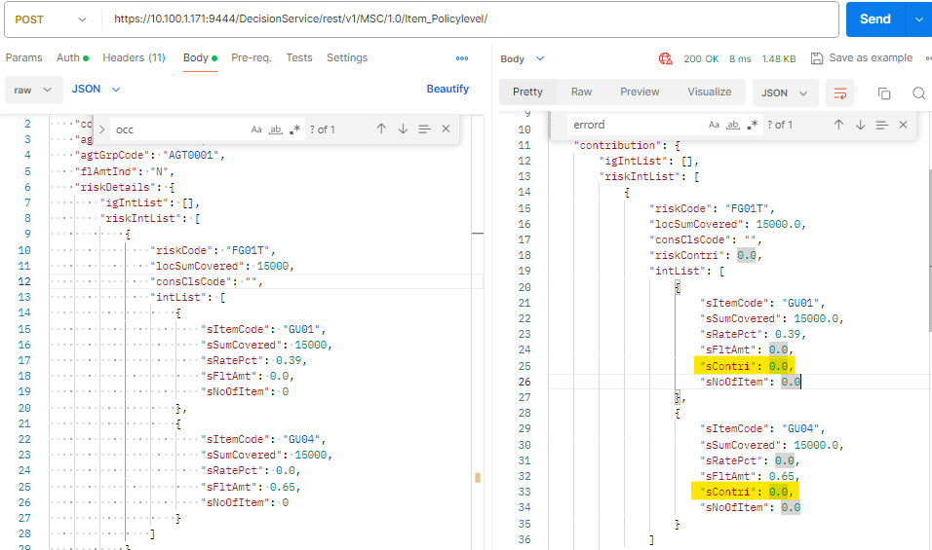

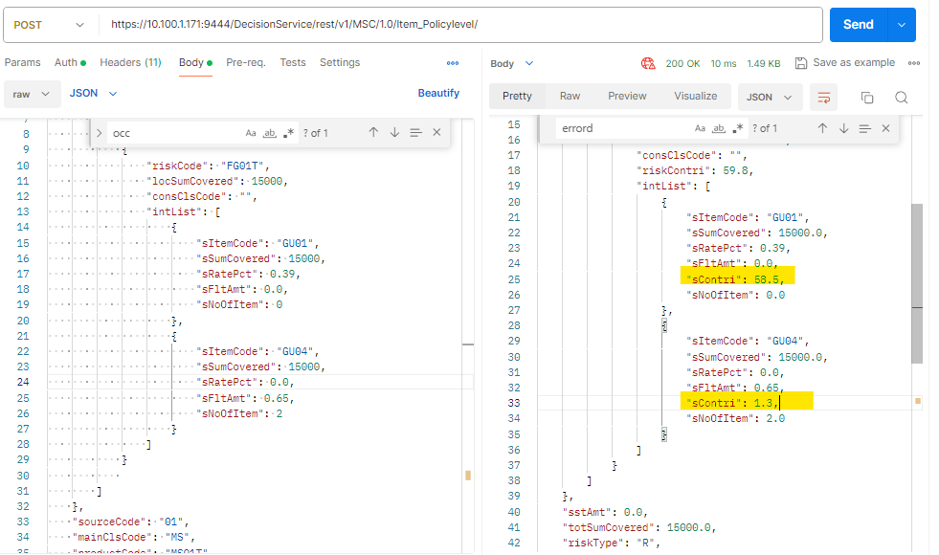

1. In IG, C-mandatory not check

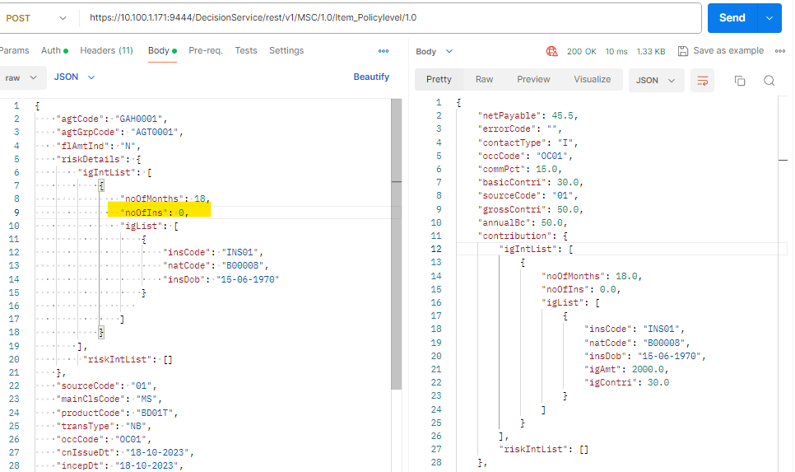

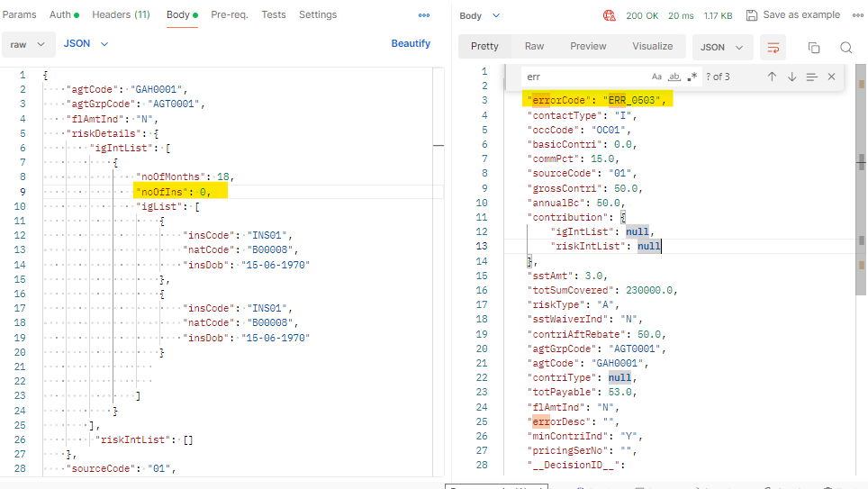

1. RisKcode validation check:

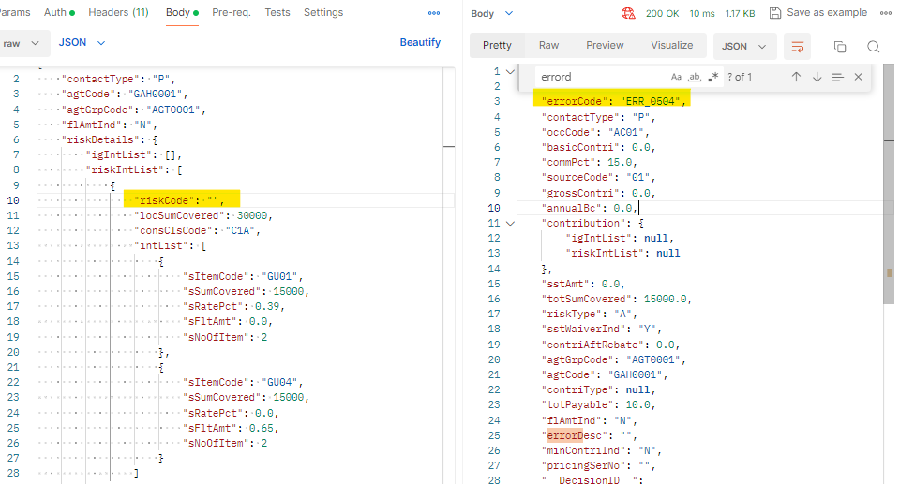

1. conClsCode validation Check:

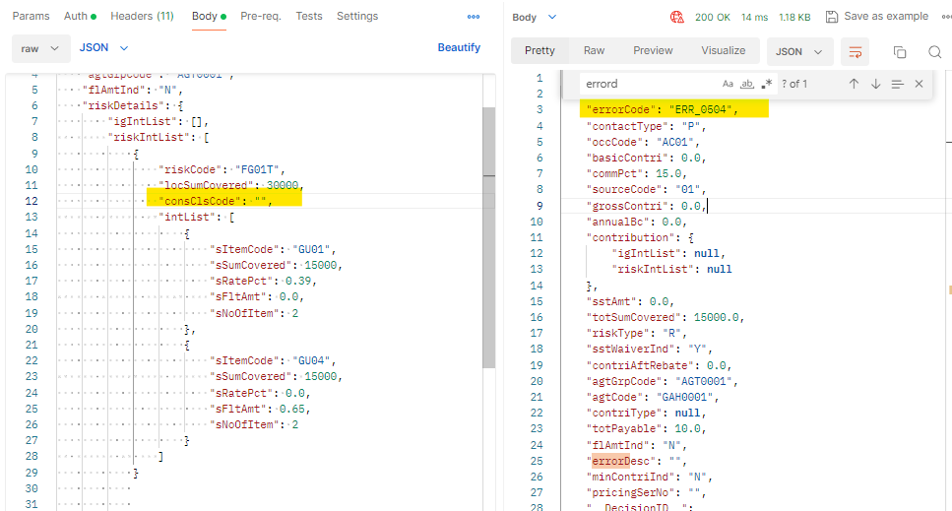

1. sItemCode validation Check:

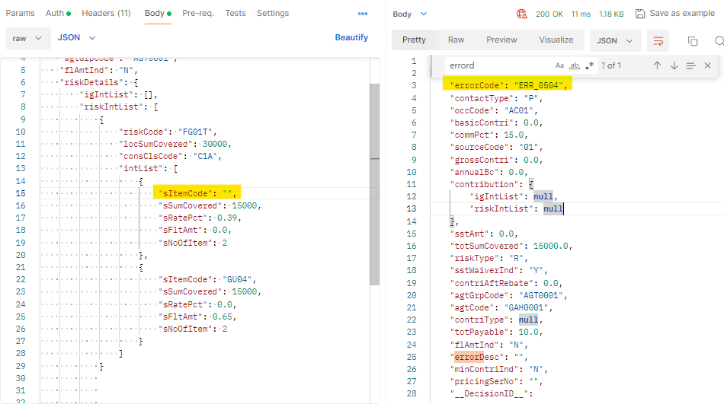

1. sRatepct validation check:

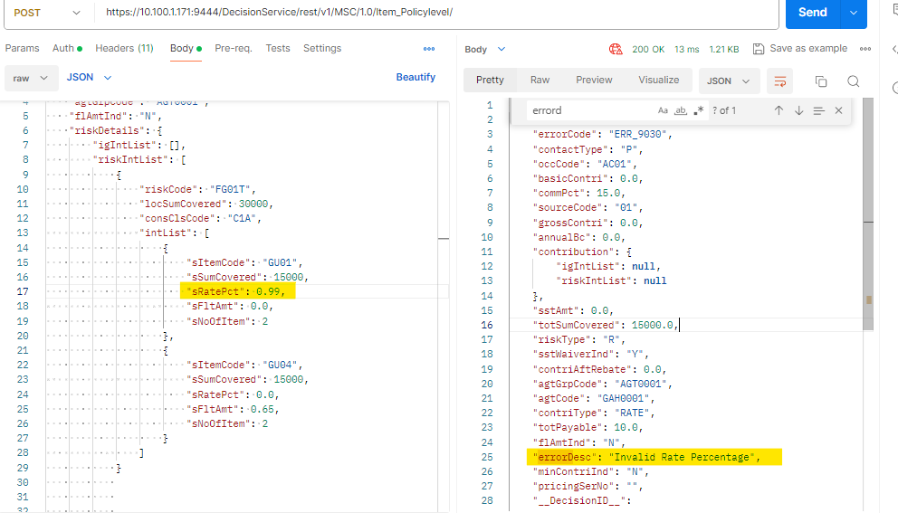

1. sNoOfItem validation check:

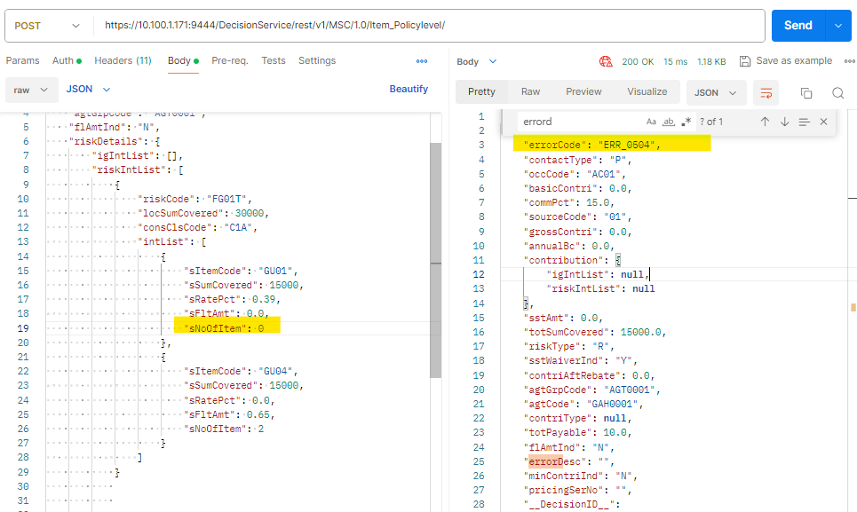

1. Do some changes in rule flow in separate branch and execute

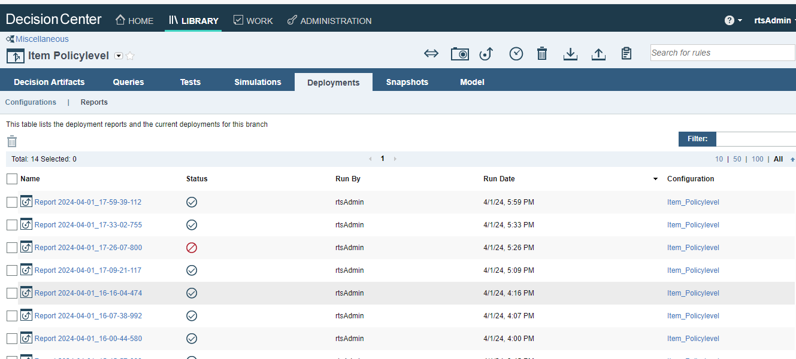

11.For Non –Ig json request:

Url is : https://10.100.1.171:9444/DecisionService/rest/v1/MSC/1.0/Item_Policylevel/

{

    "contactType": "P",

    "agtCode": "GAH0001",

    "agtGrpCode": "AGT0001",

    "flAmtInd": "N",

    "riskDetails": {

        "igIntList": [],

        "riskIntList": [

            {

                "riskCode": "FG01T",

                "locSumCovered": 30000,

                "consClsCode": "C1A",

                "intList": [

                    {

                        "sItemCode": "GU01",

                        "sSumCovered": 15000,

                        "sRatePct": 0.39,

                        "sFltAmt": 0.0,

                        "sNoOfItem": 2

                    },

                    {

                        "sItemCode": "GU04",

                        "sSumCovered": 15000,

                        "sRatePct": 0.0,

                        "sFltAmt": 0.65,

                        "sNoOfItem": 2

                    }

                ]

            }

        ]

    },

    "sourceCode": "01",

    "mainClsCode": "MS",

    "productCode": "MS01T",

    "pricingSerNo": "",

    "transType": "NB",

    "occCode": "AC01",

    "cnIssueDt": "18-08-2023",

    "incepDt": "18-08-2023",

    "expiryDt": "10-02-2024",

    "totSumCovered": 15000,

    "commPct": 15.00,

    "rebatePct": 0.00,

    "sstWaiverInd": "Y"

}

12.For IG – json request:

{

    "agtCode": "GAH0001",

    "agtGrpCode": "AGT0001",

    "flAmtInd": "N",

    "riskDetails": {

        "igIntList": [

            {

                "noOfMonths": 18,

                "noOfIns": 2,

                "igList": [

                    {

                        "insCode": "INS01",

                        "natCode": "B00008",

                        "insDob": "15-06-1970"

                    },

                    {

                        "insCode": "INS01",

                        "natCode": "B00008",

                        "insDob": "15-06-1970"

                    }

                ]

            },

            {

                "noOfMonths": 18,

                "noOfIns": 1,

                "igList": [

                    {

                        "insCode": "INS01",

                        "natCode": "B00008",

                        "insDob": "15-06-1970"

                    }

                ]

            }

        ],

         "riskIntList": []

    },

    "sourceCode": "01",

    "mainClsCode": "MS",

    "productCode": "BD01T",

    "transType": "NB",

    "occCode": "OC01",

    "cnIssueDt": "18-10-2023",

    "incepDt": "18-10-2023",

    "expiryDt": "17-06-2025",

    "pricingSerNo":"",

    "totSumCovered": 230000,

    "commPct": 15.00,

    "rebatePct": "0.00",

    "sstWaiverInd": "N",

    "contactType": "I"

}

13. For Declined case:

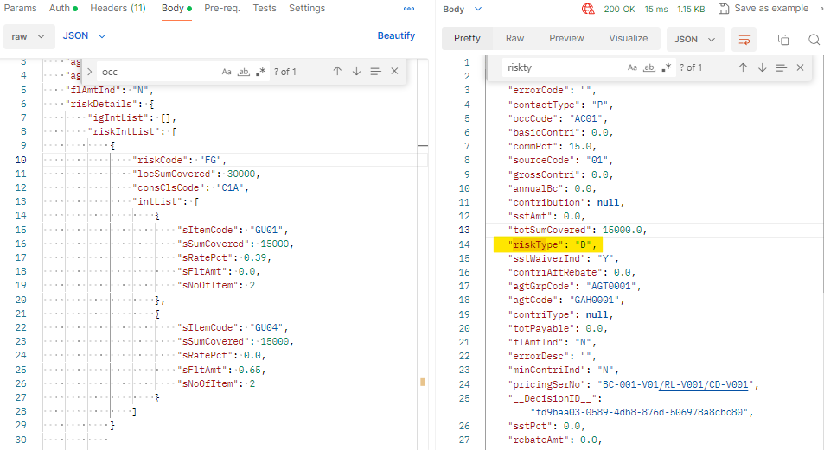

14. natCode checking:

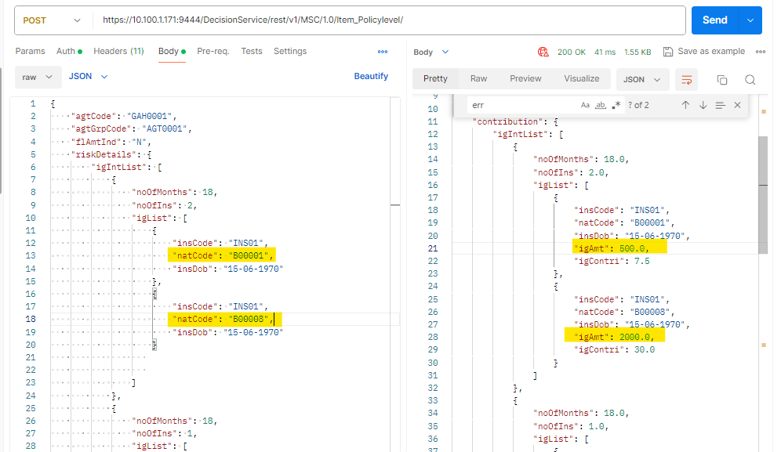

15. noOfMonths checking – if I give (20)that is not present in table, but igContri is calculated, ie igContri value is not reset, it takes the value from previous loop

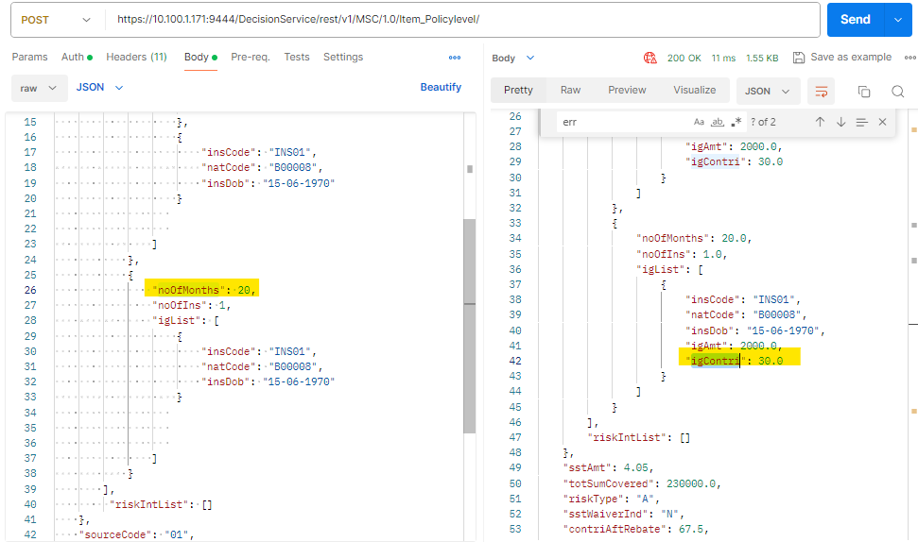

16.Error Desc missing , there is no errordesc for ERR_0504 in exception handling.

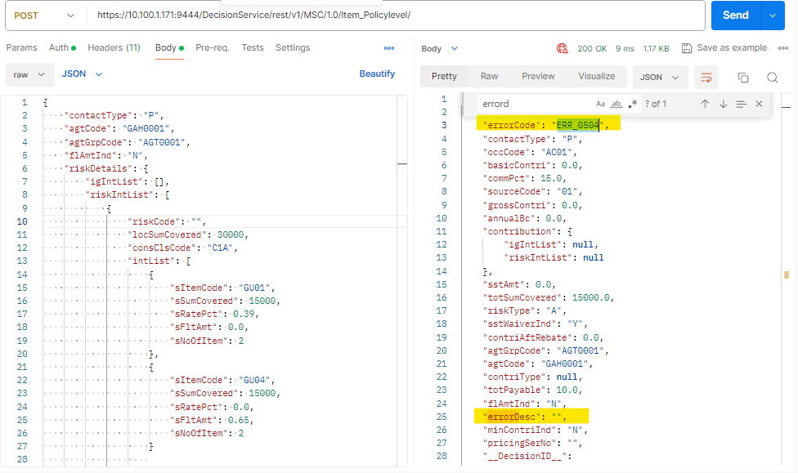

17.There is no errorcode for this description.

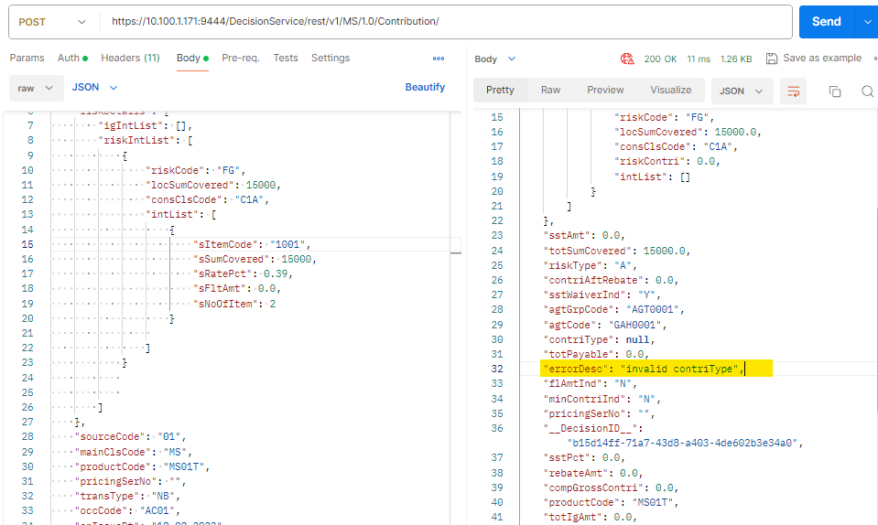

18.subRiskcode is not reassign to PIAM Code

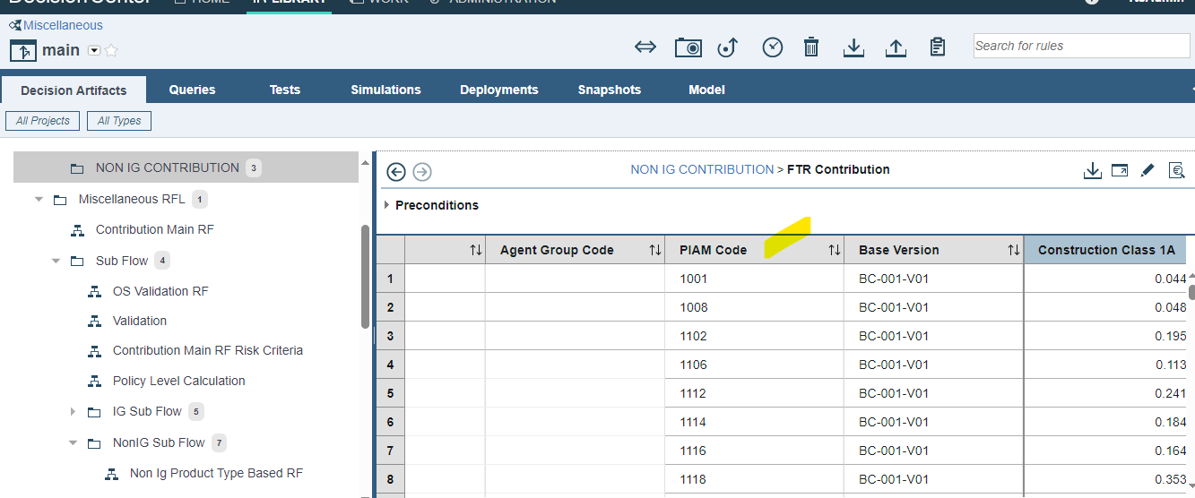

So calc is not happening – FTR Contribution.

